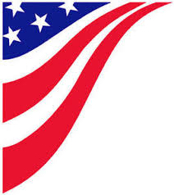
Free!!! Red, White, & Blue
Barbados Pageant
Saturday 26th at 11:30 A.M. (check in at 11:00)
Located on the Dance Floor
Theme: Red, White, and Blue
May wear anything but will get extra points for wearing red, white, and blue.
Categories:
-Best Dressed
-Best Personality
-Best Overall
Ages: 0-2, 3-6, 7-12, & 13 and up
Boys & Girls
Will combine ages if not enough participants in each group!

